
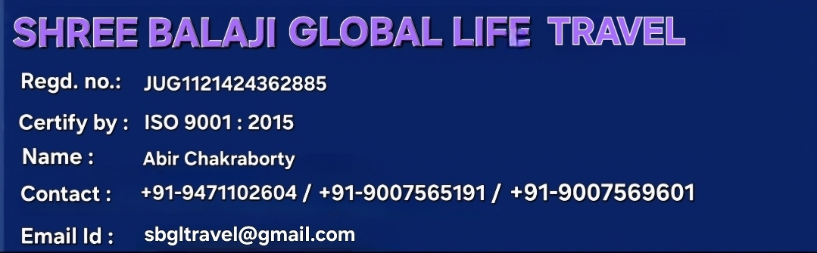



ISKCON Mayapur Tour
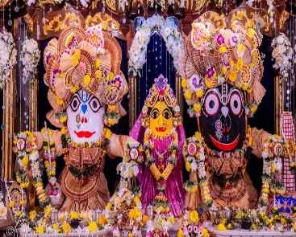
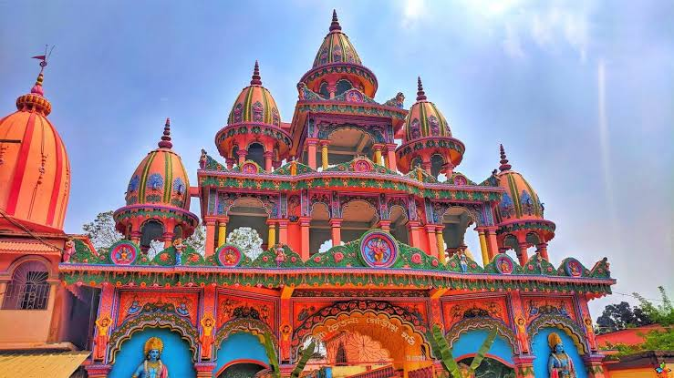


(1st Day) Tata to Howrah

(2nd Day) Iskon Sightseeing

- Iskon Puja, Visit Yoga Peeth, Chand Kazi Samadhi, Shri Chaitanya Math

(3rd Day) Howrah to Tata

Package Included:
- Meals as per itinerary (B+L+D)
- AC Hotel
- Ferry Charges
- AC Train fare (Tata to Howrah UP / DOWN)
- Tata to Iskon UP / DOWN Charges Included
- Package cost *5,400* /Rs.

Package Excluded:
- Personal Expenses
Cancellation Policy :
- Minimum Cancellation is Rs. 1000/- per Head.
- 25% Between 30-20 Days Before Tour Departure
- 50% Between 20-10 Days Before Tour Departure
- 75% Between 10-05 Days Before Tour Departure
- 100% on the Same Day & No show.

